VCA3

Comparison of Hi-End PDAs

- Assembly quality, dimensions, weight
As for the quality of the shell, the model by HP stands out from the line - most of it is made of magnesium alloy. Other handhelds feature high assembly quality, but still they are made of plastic. There is a certain backlash in FS LOOX 720 (depending on the sample) and Asus A730. In all, HP iPaq hx4700 has better assembly quality, and other models stay at the same level.

HP iPaq hx4705 is the biggest and the heaviest model (due to its large screen and capacious battery), and Asus A730W - the smallest.

 | Asus A730/A730W | HP iPaq hx4700 | FS LOOX 720 | Dell Axim X50v
Height, mm | 117.5 | 131 | 122 | 119
Width, mm | 72.8 | 77 | 72 | 73
Depth, mm | 16.9 | 14.9 | 15.2 | 16.9
Weight | 170 g | 186.7 g | 170 g | 175 g
Material | Plastic | Magnesium alloy | Plastic | Plastic
Manufacturer | Asus | HTC | HTC | HTC

All models are equipped with two slots, i.e. they are definitely bigger than single slot PDAs and weighty compared with HP iPaq 1940, for example. Many still postpone the purchase of a VGA Pocket PC waiting for smaller size solutions, however there is none at the moment. Talking about dual slot models, we can say that Dell, Fujitsu Siemens and Asus have almost optimal dimensions. You won't feel its weight or size, when the handheld rests in the pocket of the jacket or in the belt case, but not in the pocket of the shirt or jeans.

- Ergonomics
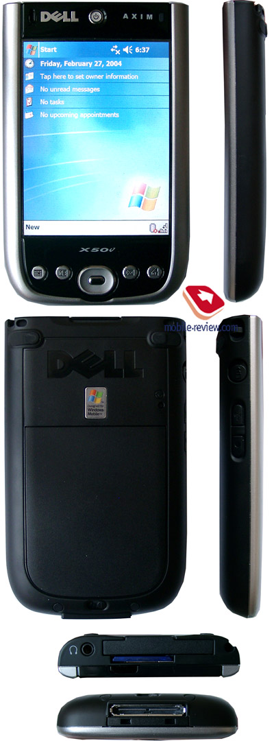

- Лицевая панель

